Honey Production: Linear Trend & Future Projection
Problem Statement
U.S. honeybee colonies have been under pressure for decades. Using state-level honey-production data (1998–2012) we ask: Is there a statistically clear long-term decline in average total production, and what does a simple linear extrapolation imply for 2050?
Solution Strategy
1. Aggregate the panel to yearly mean total production. 2. Fit ordinary-least-squares linear regression of mean totalprod on year (sklearn LinearRegression + closed-form & polyfit verification). 3. Project the fitted line to 2050. 4. Stress-test the slope with additive-noise Monte-Carlo, year-window sensitivity, and bootstrap CI for the 2050 forecast. 5. Adapt the narrative for data-literate analysts, executives, subject experts, and nonspecialists.
Solution
Slope ≈ −88 300 lbs per year (R² ≈ 0.58). The fitted line reaches near-zero production around 2052; the point forecast for 2050 is ≈ 186 500 lbs. Price per pound has risen while yield per colony has also declined, consistent with scarcity. Bootstrap 95 % interval for the 2050 prediction is wide, underscoring extrapolation uncertainty.
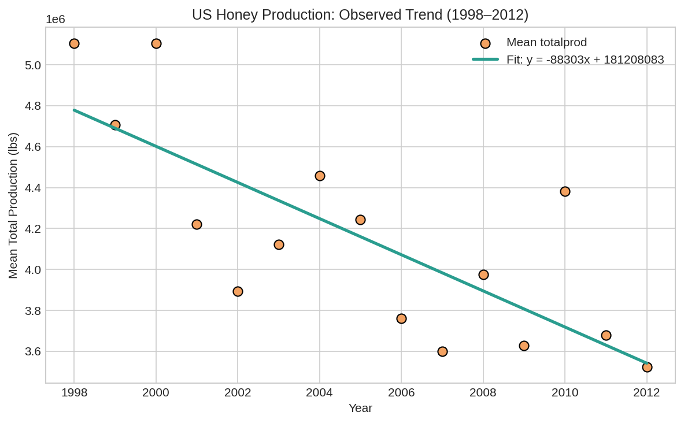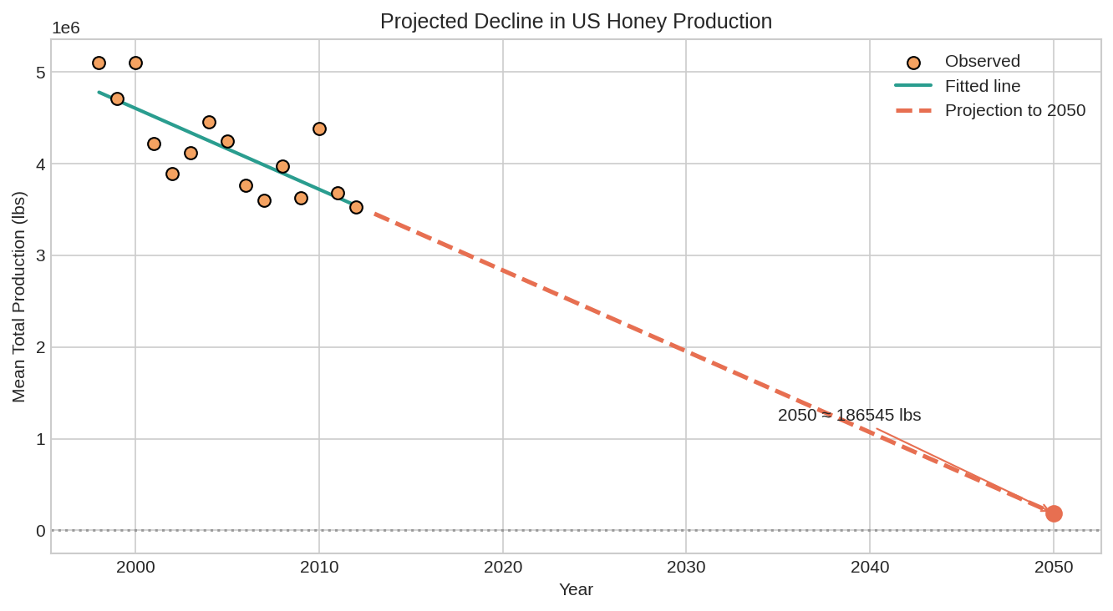
Left: observed means + OLS fit (1998–2012). Right: projection to 2050.
Key Takeaways
• Average state honey production fell ~88 k lbs each year; the linear trend explains ~58 % of the variation.
• Naïve extrapolation yields only ~186 k lbs in 2050 and crosses zero near 2052 — a stark warning, not a causal forecast.
• Results are moderately sensitive to noise and to the exact year window; always report bootstrap uncertainty.
• Communication must be audience-aware: technical detail + CI for analysts; one headline number + chart for executives; plain language for the public.

